**Methodology Achilles**

Achilles is a LSTM model able to predict the movements of Gold Vs USD commodity market. It uses data from Metatrader 5 (Platform to connect to the terminal) and is trained with roughly 360.000 rows in 6 columns. The prediction of Achilles is integrated in a trading for total automation and sentiment analysis to make inference in a demo account. The 30 days period of testing we experimented a return of 160% from the starting budget $1000.

The data is collected directly from the MetaTrader demo account directly with the integration in python. We’re extracting data minute-per-minute since 2016 until now. We decided to keep the open, high, low, close, tick_volume, RSI and EMA values and technical indicators to feed into our model.

We decided to chose the ETH-USD crypto currency for it’s special volatility like the real movements of the Gold Vs USD and the large amount of data available. We didn’t choose directly the XAUUSD symbol due to possible overfitting we experimented with backward prediction and forward prediction.

To preprocess our data, we applied normalization with MinMaxScaler and we used a windowed approach. A windowed approach is a popular way of preprocessing Time Series data, we are splitting the data each 20 minutes to create slices and then we pass these slices to our model to improve the performance of our model. We found this approach extremely useful when predicting the XAUUSD Prices minute-per minute.

Achilles is a small LSTM Neural network with roughly 10k parameters and three layers. The input layer has input shape (None, 120, 35) and 35 neurons. The second layer has 20 neurons and the output layer has 1 neuron.

After experimented with around 50 possible models in contradiction to our intuition models with fewer neurons have the best accuracy in backward prediction. We found this model to be the best between number of parameters and speed in inference and training.

Models with more parameters tend to overfit too much on the data provided or will never achieve convergence.

In backward testing we achieved results such as:

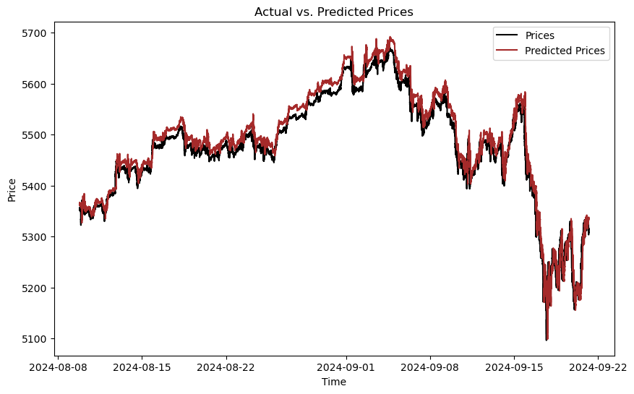

Our model is able to predict the prices with a R2 score of 90% in backward testing. To put our model into forward prediction we initialize how a blank list called predictions = [] we decided to predict two months of data in Gold Vs USD; to accomplish this problem we used the last 2 months of data to predict the next minute. Then we used the last day and 23.59 minutes of the real movements plus the minute we predicted previously to predict another minute and so on.

By doing this we ensure our model will have accurate predictions without returning the last two months of data that’s a problem we needed to overcome in many of our experiments.

Predicting a 100% the movement of the XAUUSD commodity is a impossible task even for humans 200 years beyond us. We don’t have the technology to predict the future until this day, but we want Achilles to recognize hidden pattern in the data provided and use them in forward prediction. The last predictions of our model look promising. However, we need further develop to put our model into a live account if we want to start doing trading with it.

Image 1 ( Predictions of Achilles December 4th to 6th)

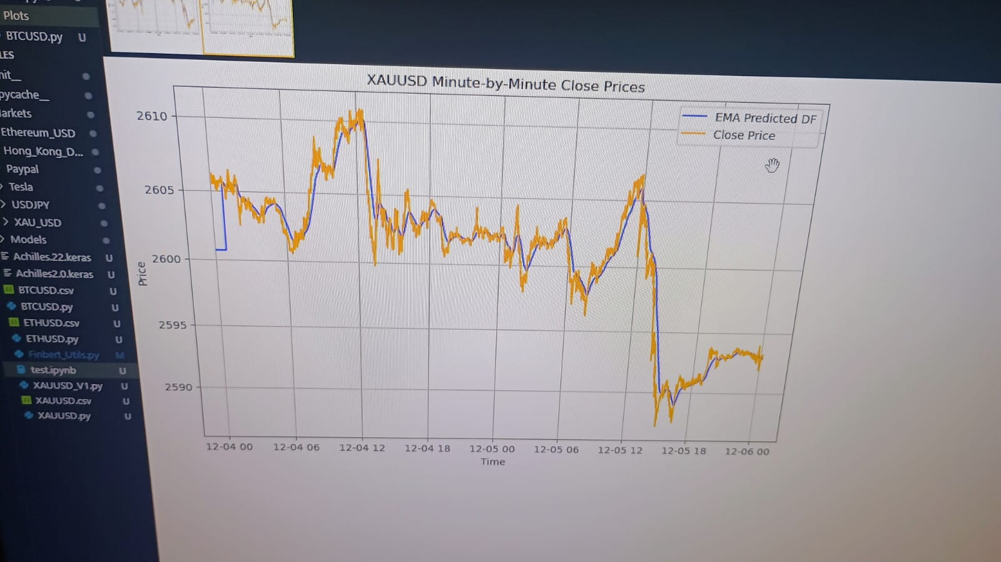

Image 2 (Real movements of XAUUSD from December 4th to 6th)

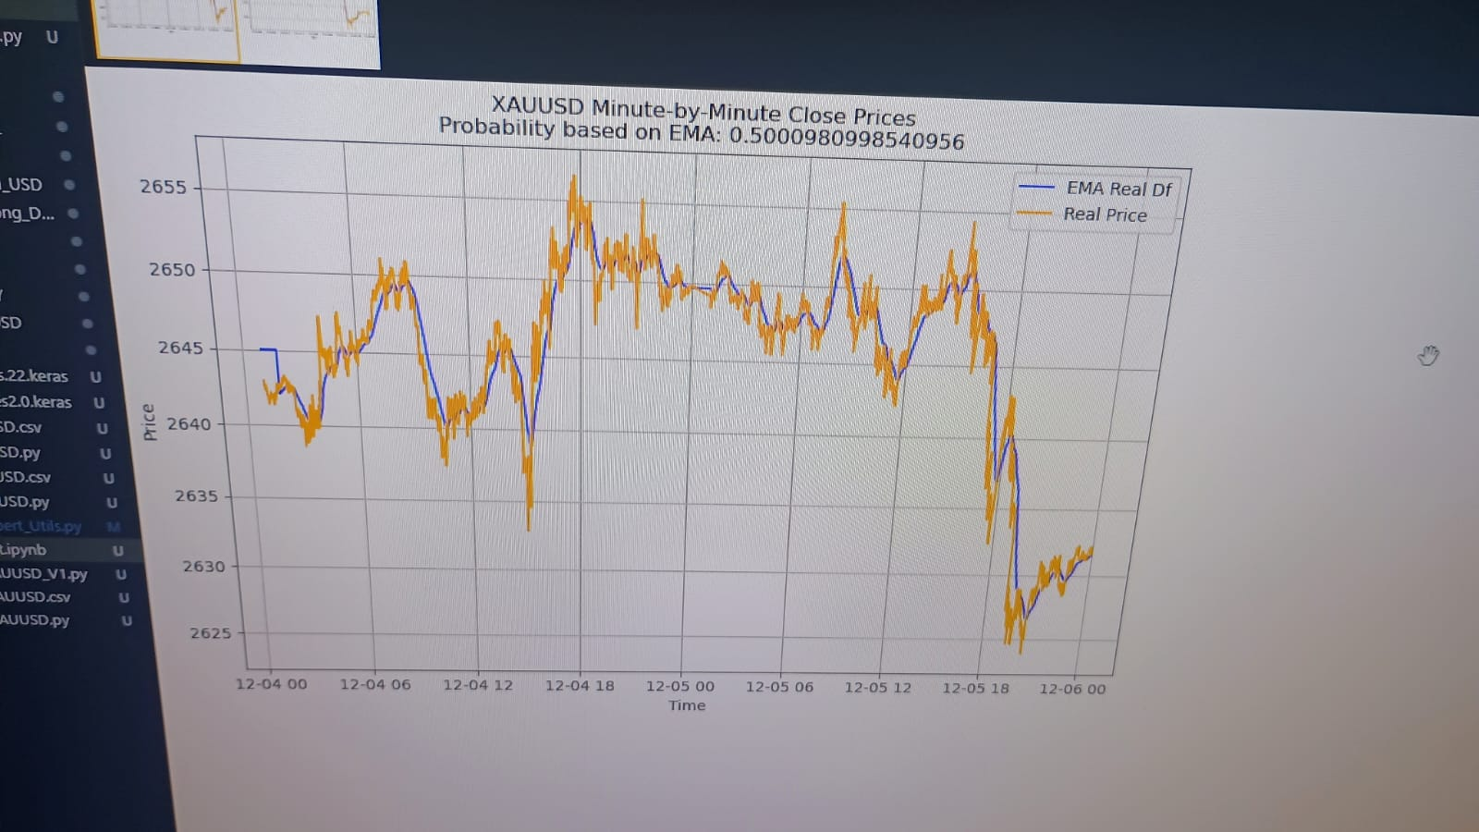

As you can see Achilles can mimic the movements of the commodity with a fair precision. We predict data during 2 months and use the predictions in our trading bot.

For this task we use the bot with a slice of data, 10 minutes before the now’s minute and 9 minutes beyond the now’s minute. We then calculate the lowest and highest price in the slice of 20 minutes to buy in the lowest price, sell in the highest price and take profit when the price goes up and down respectively.

This way our bot is able to use the predictions from Achilles and use them in inference to invest in the stock market.

In addition, we used FinBERT a specialized sentiment analysis model to check the sentiment and probability of the latest news in the market. The news we used are from three different websites. Bloomberg, Benzinga and Investing.com. These news webpages are characterized for their unbiased news and high accuracy showing the sentiment of the market. We scrap the title and the contents of the news webpages. In each webpage we can scrap roughly 10-15 news each time. Each 15 minutes the bot checks the latest news on the webpages and extract the titles and contents for sentiment analysis and determine if it’s a right moment to invest with the average probability of all the news. The probability is a range from 0.0 to 1.0 and the sentiments can be “positive”, “negative” or “neutral”.

To invest we use a simple logic. If the sentiment is positive and the probability is >= 0.87 we will buy if the now’s price is the highest in the slice of data. If the sentiment is negative and the probability is <= 0.50 we will sell if the now’s price is the lowest in the slice of data we take of the model. Otherwise we won’t invest and keep running.

For experimentation we used a demo account with $1000 capital. For positional sizing we decided to use a 30% of our total balance to invest in the commodity. The demo account did have a leverage of 1:100 which is risky but with our predictions we’re able to tolerate this risk.

Achilles is still not a 100% accurate for this reason we decided to put some limitations to its orders. We’re retrieving the latest 17 minutes from the real XAUUSD price. If the now’s price is the highest we won’t buy or take profits of sell orders (Because when you are trying to sell you expect the price to go down). Makes no sense to buy when the price is the highest as we are trying to invest when the price is the lowest.

The same for selling, if the now’s price is the lowest we won’t sell or take profit of buy orders (When you’re buying you expect the price to go up). As makes no sense to sell when the price is the lowest in the real DataFrame and not in the predicted DataFrame.

Image 3 (Logic of Achilles)

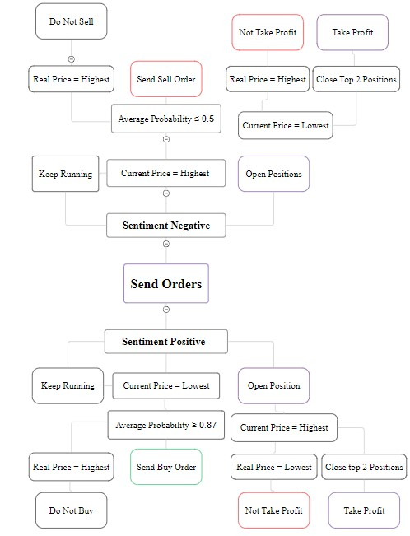

We have the inner loop; its task is to check the sentiment each 15 minutes from the three different websites and extract sentiment and news. We use Beautiful Soup, and request to scrap the data and then we feed the text data to FinBERT to extract the probability and sentiment needed.

Our Outer Loop will run each minute. This is because our model was trained in minute-per-minute data and we want to capture fluctuations of the symbol to invest just in the right moment and take the profit either of buy or sell orders.

For this task we use data preprocessing to extract the slice of data and check the current minute each time the bot is running. When we have the now’s minute always in mind, we then can extract the 10 minutes before the now’s minute and the 9 minutes beyond our now’s minute. With this slice of data, we plan to use our trading logic.

Image 4 (Trading Bot Structure)

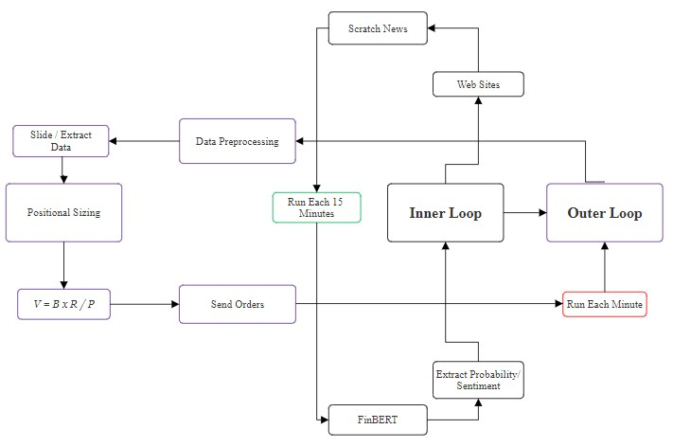

Then we use the positional sizing explained before to invest and send orders in the demo account. After a period of 30 days the results of our experimentation were successful since we have a return of 160%. Details are shown in the next image.

Image 5, profit of our model:

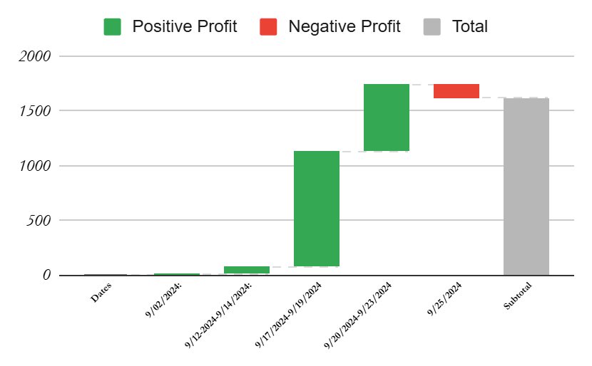

In a month we take $1621.52 in profit from the XAUUSD commodity market. The model outperforms some of the most popular models. Due to it’s fast convergence and the capability to generalize well being trained in ETH-USD data from 2016.

Table 1 (Difference between our model and classic approaches)

|  |  |  |  |
| --- | --- | --- | --- |
| Approach | Testing loss | MAE | MAPE |
| Fin-BERT  Embedding LSTM | 0.00083 | 173.67 | 0.045 |
| LSTM | 0.00092 | 183.36 | 0.072 |
| DNN | 21.77 | 489.32 | 0.22 |
| Achilles | 0.0033 | **22.905** | **0.009** |

Achilles is still not able to predict the XAUUSD market at a 100% R2 score. There are many situations where Achilles can’t output the real movements of such a market, but integrated with a good positional sizing, risk management and other tools such as sentiment analysis can be really profitable in the short term and automated with a trading bot.

The Achilles heel is the incapability to trade in other markets than the Gold Vs USD. This market has patterns that have repeated for more than 4000 years and will do in the future but other markets like forex, indices and stocks don’t have such a large history and thus are not as predictable as XAUUSD. We are experimenting in USDJPY for its versatility and profitability in short term. More experiments need to be done to predict other commodities such as Crude Oil vs USD or Forex Like US dollar vs Japanese Yen.

Angel Varela

+57 302-663-4759

[Angel.daniel.varela25@gmail.com](mailto:Angel.daniel.varela25@gmail.com)

Independent Researcher

ORCID: https://orcid.org/0009-0003-7032-0392